*VSI: Solid state battery*

**Supplementary Materials**

**Na3NH2B12H12 as** **High Performance Solid Electrolyte for All-solid-state Na-ion Battery Application**

Liqing He,† Huaijun Lin,‡ Hai-Feng Li,∑ Yaroslav Filinchuk,⊥ Junjun Zhang,† Ying Liu,† Mingyang Yang,† Yan Hou,† Yonghong Deng,*,† Hai-Wen Li,# Huaiyu Shao,*,∑ Liping Wang,€ Zhouguang Lu*,†

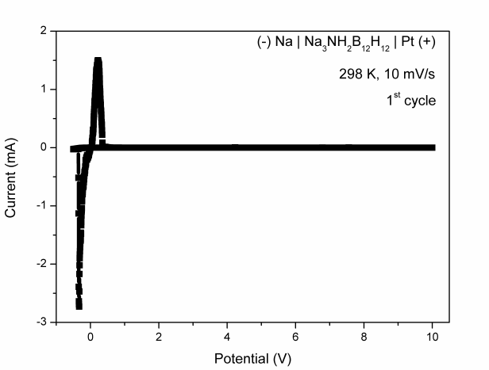

**Figure S1.** Cyclic voltammogram of Na3NH2B12H12 sandwiched between the Na and Pt electrodes at room temperature with a voltage scan rate of 10 mV/s (1st cycle).





**Figure S2.** TG-DTA profiles of (a) Na3NH2B12H12, (b) NaNH2 and (c) Na2B12H12.



**Figure S3.** XRD pattern of Na3NH2B12H12 heated up to 723 K (5K/min).







**Figure S4.** Impedance plots for Na3NH2B12H12 measured at various temperatures during heating run.



**Figure S5.** Coulombic efficiency over 200 cycles of all-solid-state TiS2/Na3NH2B12H12 | Na3NH2B12H12 | Na rechargeable battery operated at 353 K and 0.1 C.



**Figure S6.** XRD pattern of Na3NH2B12H12 electrolyte after 200 discharge/charge cycles in all-solid-state TiS2/Na3NH2B12H12 | Na3NH2B12H12 | Na battery (353 K, 0.1 C and 1.0 ~ 2.4 V).

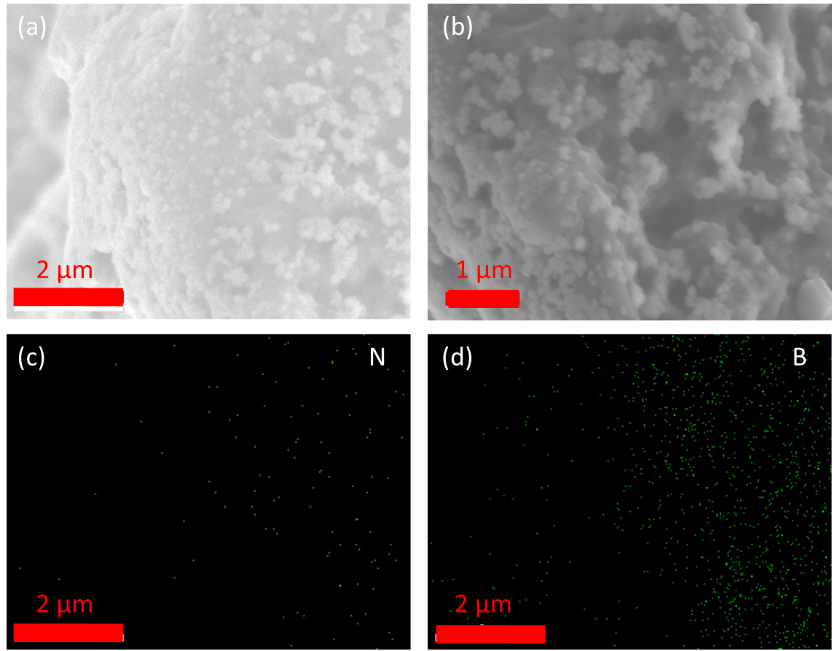

**Figure S7.** (a-b) SEM images and (c-d) EDAX elemental mapping of the Na3NH2B12H12.

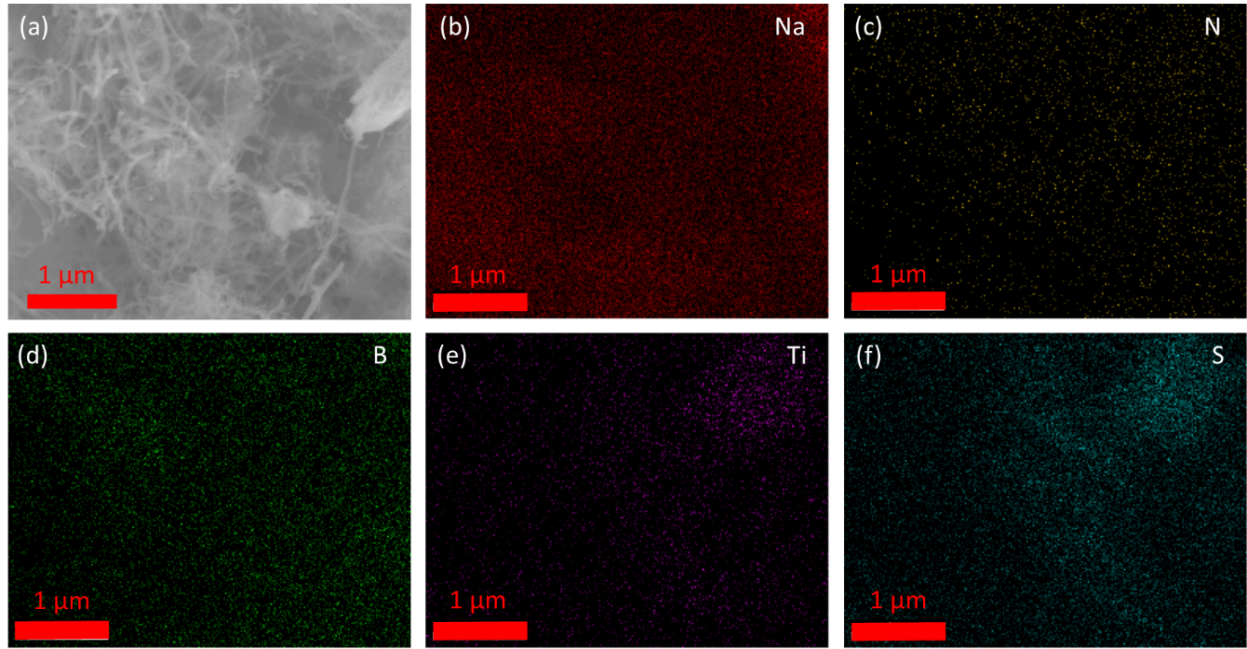

**Figure S8.** (a) SEM image and (b-f) EDAX elemental mapping of the TiS2/Na3NH2B12H12 positive electrode.

**Table S1.** Refined room-temperature structural parameters of Na3NH2B12H12 compound as well as the goodness of fit. We refined the overall debye-waller factor as B = 2.37(16) Å2. Here OF = occupation factor.

